Infrastructure description for [www.enigmahpai.org](http://www.enigmahpai.org)

The domain enigmahpai.org is bought by Carsten Kirkeby from ionos.co.uk and redirects to ckirkeby.github.io (public page) via DNS. It has a Business SSL to make it accessible from all large companies and institutions. The index.html page redirects to the shiny server page (actually embedding the shiny page within the index.html page). It is important that the folder on github has a readme.md file, a LICENSE and a CNAME file (to communicate with the DNS server). It is also important that enigmahpai.org is kept as custom domain in the github folder (Settings-Pages-Custom domain).

The shiny server location is:

<https://ljkjaer.shinyapps.io/ENIGMA/>

Data update procedure from December 2023:

Every Monday WOAH uploads a new data snapshot to <https://login.microsoftonline.com/f1faf563-b06d-4c35-8739-34ccc280dcaf/oauth2/authorize?client%5Fid=00000003%2D0000%2D0ff1%2Dce00%2D000000000000&response%5Fmode=form%5Fpost&response%5Ftype=code%20id%5Ftoken&resource=00000003%2D0000%2D0ff1%2Dce00%2D000000000000&scope=openid&nonce=96562796C51537EE33A98569F6CB6115423F27192EF8C2CC%2DF496FCBC642E83A63F225D11801C1FBDB55FEC58A4F8FAEB796490CDB09E4664&redirect%5Furi=https%3A%2F%2Foieoffice365%2Esharepoint%2Ecom%2F%5Fforms%2Fdefault%2Easpx&state=OD0w&claims=%7B%22id%5Ftoken%22%3A%7B%22xms%5Fcc%22%3A%7B%22values%22%3A%5B%22CP1%22%5D%7D%7D%7D&wsucxt=1&cobrandid=11bd8083%2D87e0%2D41b5%2Dbb78%2D0bc43c8a8e8a&client%2Drequest%2Did=4548f9a0%2Dd092%2D7000%2De777%2D7a9109979a81>

Lene Jung Kjær and Carsten Kirkeby have access to this sharepoint database.

Every Monday, Carsten is going to download the latest data snapshot, put it in the folder C:\Users\zxd598\Documents\GitHub\ckirkeby.github.io\ENIGMA2023 and run the code “formatting_code_24102024.R” which updates the “for_ai.car” file that has data prepared for the model to run in shiny.

Carsten then commits the changes in the github folder (i.e. the “for_ai.car” file), and upload it through the github desktop program. Then the new data is available to the shiny server in about 10 minutes.

The shiny script (including folders www, data and src) are also kept within the same folder on github.

Snapshot of the enigmahpai.org page, 2023-12-19:

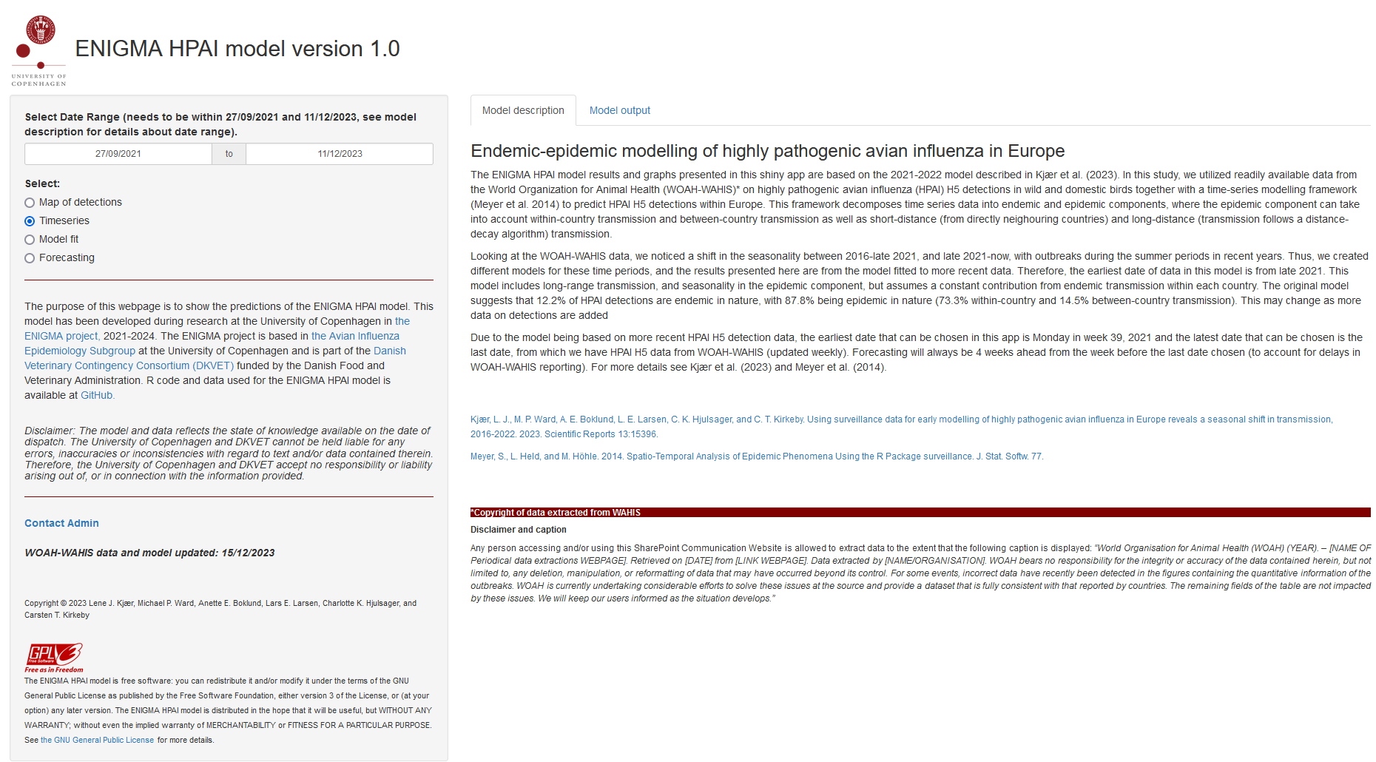

Text:

The purpose of this webpage is to show the predictions of the ENIGMA HPAI model. This model has been developed during research at the University of Copenhagen in [the ENIGMA project,](https://ivh.ku.dk/forskning/dyrevelfaerd-og-sygdomsbekaempelse/projektside/enigma/) 2021-2024. The ENIGMA project is based in [the Avian Influenza Epidemiology Subgroup](https://ivh.ku.dk/english/research/animal-welfare-and-disease-control/avian-influenza-epidemiology/) at the University of Copenhagen and is part of the [Danish Veterinary Contingency Consortium (DKVET)](https://dkvet.dk/english/about/) funded by the Danish Food and Veterinary Administration. R code and data used for the ENIGMA HPAI model is available at [GitHub.](https://github.com/ckirkeby/ckirkeby.github.io/tree/main/ENIGMA2023)

##### *Disclaimer: The model and data reflects the state of knowledge available on the date of dispatch. The University of Copenhagen and DKVET cannot be held liable for any errors, inaccuracies or inconsistencies with regard to text and/or data contained therein. Therefore, the University of Copenhagen and DKVET accept no responsibility or liability arising out of, or in connection with the information provided.*

[**Contact Admin**](mailto:ckir@sund.ku.dk)

**WOAH-WAHIS data and model updated: 15/12/2023**

Copyright © 2023 Lene J. Kjær, Michael P. Ward, Anette E. Boklund, Lars E. Larsen, Charlotte K. Hjulsager, and Carsten T. Kirkeby

  
The ENIGMA HPAI model is free software: you can redistribute it and/or modify it under the terms of the GNU General Public License as published by the Free Software Foundation, either version 3 of the License, or (at your option) any later version. The ENIGMA HPAI model is distributed in the hope that it will be useful, but WITHOUT ANY WARRANTY; without even the implied warranty of MERCHANTABILITY or FITNESS FOR A PARTICULAR PURPOSE. See [the GNU General Public License](https://www.gnu.org/licenses/) for more details.

### Endemic-epidemic modelling of highly pathogenic avian influenza in Europe

The ENIGMA HPAI model results and graphs presented in this shiny app are based on the 2021-2022 model described in Kjær et al. (2023). In this study, we utilized readily available data from the World Organization for Animal Health (WOAH-WAHIS)* on highly pathogenic avian influenza (HPAI) H5 detections in wild and domestic birds together with a time-series modelling framework (Meyer et al. 2014) to predict HPAI H5 detections within Europe. This framework decomposes time series data into endemic and epidemic components, where the epidemic component can take into account within-country transmission and between-country transmission as well as short-distance (from directly neighouring countries) and long-distance (transmission follows a distance-decay algorithm) transmission.

Looking at the WOAH-WAHIS data, we noticed a shift in the seasonality between 2016-late 2021, and late 2021-now, with outbreaks during the summer periods in recent years. Thus, we created different models for these time periods, and the results presented here are from the model fitted to more recent data. Therefore, the earliest date of data in this model is from late 2021. This model includes long-range transmission, and seasonality in the epidemic component, but assumes a constant contribution from endemic transmission within each country. The original model suggests that 12.2% of HPAI detections are endemic in nature, with 87.8% being epidemic in nature (73.3% within-country and 14.5% between-country transmission). This may change as more data on detections are added

Due to the model being based on more recent HPAI H5 detection data, the earliest date that can be chosen in this app is Monday in week 39, 2021 and the latest date that can be chosen is the last date, from which we have HPAI H5 data from WOAH-WAHIS (updated weekly). Forecasting will always be 4 weeks ahead from the week before the last date chosen (to account for delays in WOAH-WAHIS reporting). For more details see Kjær et al. (2023) and Meyer et al. (2014).

[Kjær, L. J., M. P. Ward, A. E. Boklund, L. E. Larsen, C. K. Hjulsager, and C. T. Kirkeby. Using surveillance data for early modelling of highly pathogenic avian influenza in Europe reveals a seasonal shift in transmission, 2016-2022. 2023. Scientific Reports 13:15396.](https://doi.org/10.1038/s41598-023-42660-7)

[Meyer, S., L. Held, and M. Höhle. 2014. Spatio-Temporal Analysis of Epidemic Phenomena Using the R Package surveillance. J. Stat. Softw. 77.](https://doi.org/10.18637/jss.v077.i11)

#### *Copyright of data extracted from WAHIS

##### Disclaimer and caption

Any person accessing and/or using this SharePoint Communication Website is allowed to extract data to the extent that the following caption is displayed: *“World Organisation for Animal Health (WOAH) (YEAR). – [NAME OF Periodical data extractions WEBPAGE]. Retrieved on [DATE] from [LINK WEBPAGE]. Data extracted by [NAME/ORGANISATION]. WOAH bears no responsibility for the integrity or accuracy of the data contained herein, but not limited to, any deletion, manipulation, or reformatting of data that may have occurred beyond its control. For some events, incorrect data have recently been detected in the figures containing the quantitative information of the outbreaks. WOAH is currently undertaking considerable efforts to solve these issues at the source and provide a dataset that is fully consistent with that reported by countries. The remaining fields of the table are not impacted by these issues. We will keep our users informed as the situation develops.”*

Number of reported highly pathogenic avian influenza (H5 subtype) detections shown over time between 27/09/2021 and 11/12/2023, summed over 37 European countries.